CARMEL ENGLISH SCHOOL, Kallata

Holiday Homework (2019-2020)
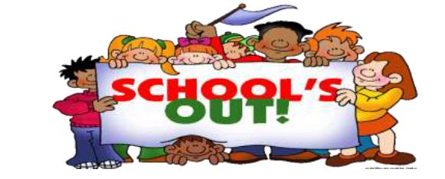
Standard – IV (First Week)

Dear children,
Be Creative

We are sure that all of you would have made plan for a fun filled summer vacation. We wish you that enjoy long break with your parents, family and friends .Try to utilize your time in such a way that you are able to sharpen your intellect as well as tone up your body by doing exercises. Read, play and enjoy.
Submit your homework to your subject teacher on the reopening day after the vacation. Be systematic; decide how many days a week you want to spend doing the homework on each subject. Gather the things you need for the respective subjects so that you do not have to waste time in searching for them. Wish you all a safe, healthy, memorable and a happy summer vacation.

GENERAL INSTRUCTIONS
- Complete all the activities during the vacation.
- All the work should be handwritten.
- Original drawings/illustrations and creative use of material will be appreciated.
- All the activities should be done on the A4 size paper.
- Parents are requested to just guide the children to complete the task of their own.

English :

Read Lesson 2 (Flying together )
and write all the difficult words with meaning
List as many summer activities as you can.

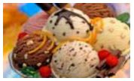
Draw some common flavors of ice –cream
in each of the brands.

Maths :
Complete Textbook Exercise IA
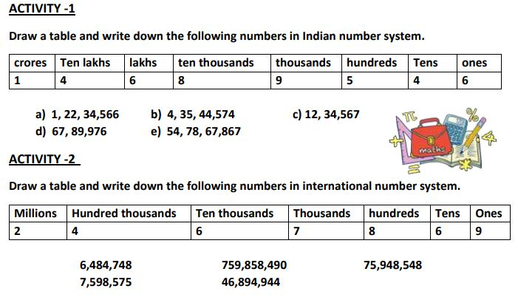
Write the multiplication tables from 11 to 25 and remember it.

Enjoy your summer holidays with lots of Fun

