CARMEL ENGLISH SCHOOL, Kallata

Holiday Homework (2019-2020)
Standard – VI (First Week)

Dear children,
Be Creative

We are sure that all of you would have made plan for a fun filled summer vacation. We wish you that enjoy long break with your parents, family and friends .Try to utilize your time in such a way that you are able to sharpen your intellect as well as tone up your body by doing exercises. Read, play and enjoy.
Submit your homework to your subject teacher on the reopening day after the vacation. Be systematic; decide how many days a week you want to spend doing the homework on each subject. Gather the things you need for the respective subjects so that you do not have to waste time in searching for them. Wish you all a safe, healthy, memorable and a happy summer vacation.

GENERAL INSTRUCTIONS
- Complete all the activities during the vacation.
- All the work should be handwritten.
- Original drawings/illustrations and creative use of material will be appreciated.
- All the activities should be done on the A4 size paper.
- Parents are requested to just guide the children to complete the task of their own.

English :
See the picture and asked to find out the answers of the questions given below.

a) What do you think the child is doing?
b) Why, do you thinkhe/ She is doing it?
c) What do you think they must have felt?

I. The Child
II. The old lady

2. Imagine that you have been selected to deliver a speech on the occasion of Independence Day think of what you would like to express and write in Your English note book.

3. Learn and Write 20 Synonyms and Antonyms and also make the sentence in Grammar Portion 4. You are not getting water supply to your Locality, Write an application to your Municipality office to provide you water supply in time.

Social Science
- Compare the Medieval period in India and Europe.
- Make a placard for a rally on World Environment Day.
- Look at your surroundings and make a list of Natural and Human made components and draw the picture ofit .
- All of us are guilty of harming the atmosphere in some way or the other Think hard and write down the activities you do during any given day which prove harmful, even in a small measure.
- Although our constitution forbids any form of discrimination, it still exists in our society. What are your views on this? What would you do to change this, if you had the power?

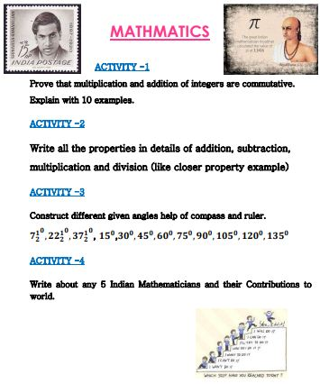

Enjoy your summer holidays with lots of Fun

